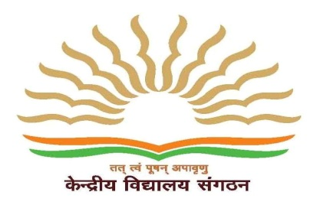

**KV 3 FARIDABAD**

**SPORTS ACHIEVEMENT**

**2019-20**

**Regional Sports Meet Total Participants=69**

Gold =14

Silver =06

Bronze =15

**National Sports Meet Total Participants=09**

Gold =05

Silver =01

Bronze =01

**SGFI Total Participants=03**

Medals =NIL

* SBSB Activities completed
* SBSB Cards of all students downloaded successfully.